There are some students.

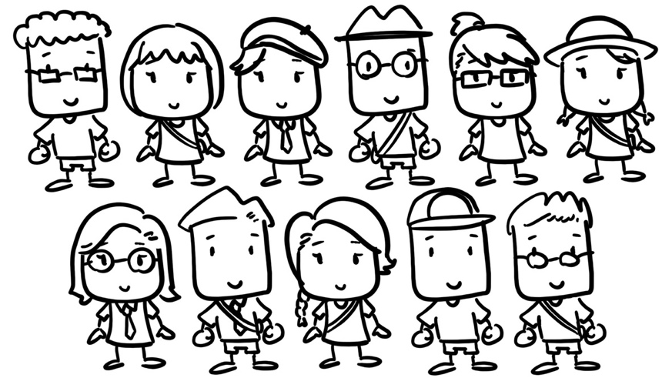

- How many boys and how many girls are there? Find the total number of students.
Count and record your results in the ten-frames.
 |  |  |  |  |  |  |  | ○ | ○ | ○ | ○ | ○
 |  |  |  |  |  |  |  | ○

Combine your findings.
$$5+6=11$$
 |  |  |  |  |  | ○
○ | ○ | ○ | ○ | ○

- How many students wear glasses and how many don’t?

no

Combine your findings.

- Find some other features of the students from the figure.

Combine your findings.

