- Check which of the following could be folded into a cube:

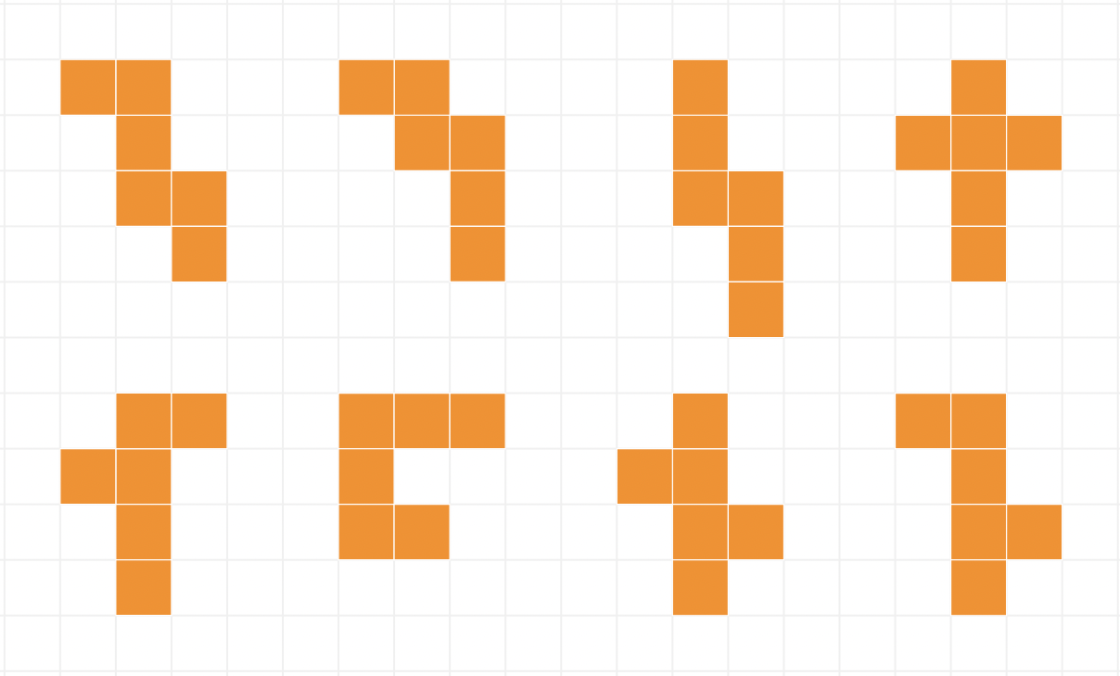
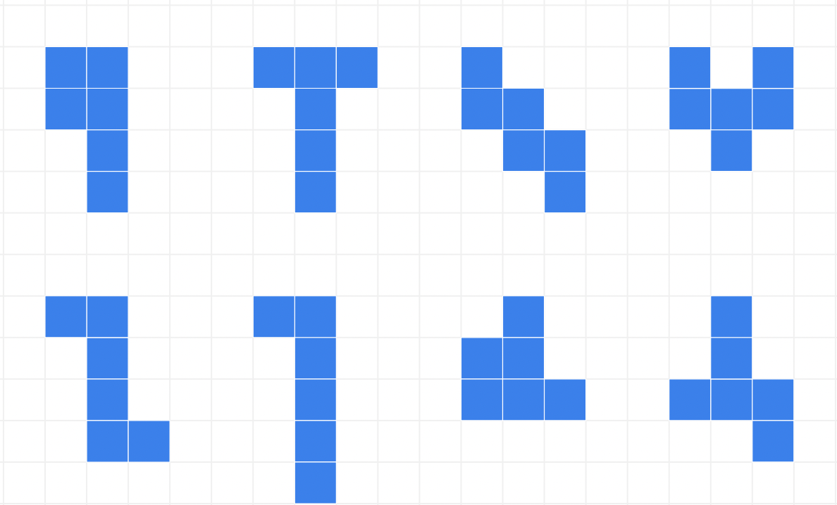

- With diagrams, explain the condition(s) for a valid net.

- Do you have any other observations?

This Mathigon activity is prepared for you to visualise the folding process of the nets:

