Exploration on Nets of a Cube
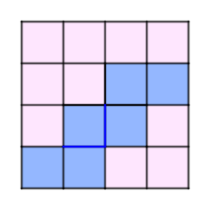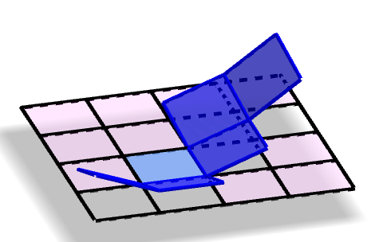

Design Rationale
- Allow students to understand that a cube can be folded from different nets
- Students learn to explore systematically and verify their guesses by testing
- Computational thinking skills could be developed

Materials
- Pieces of square paper
- A pair of scissors

Procedure
- Make 16 identical small squares by folding
- Colour 6 connected squares to make a net
- Cut and try to test if the potential net is valid or not
- Record the result
- Try to identify condition(s) for a valid net

Remarks for Teachers
- Encourage students to share among themselves
- May introduce some competition elements to increase student engagement
- Ask students to make a plan to explore different possibilities
If they can’t, give some examples and allow them to further explore
- Even an invalid net is valuable for figuring out why it doesn’t work

Exploration on Nets of a Cube (Record Sheet)

Experiment Record
- Shade or colour to show the net
- If it is a valid net, give a tick (✓)

Can you think of some rule(s) for a valid or invalid net?

Do you have other observations or opinions?

