P2 Mathematics
Amanda Bean’s Amazing Dream
1. Look at the shelf below and answer the questions.

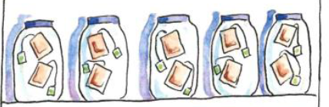
a) How many equal groups of teabags are there?
There are __________ equal groups of teabags.

b) How many teabags are there in each group?
There are ___________ teabags in each group.

c) There are _________ groups of two.

d) ____ + ____ + ____ + ____ + ____

e) Written as: ______ x ______

2. Look at the shelf below and answer the questions.

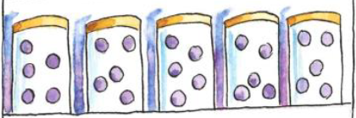

a) How many equal groups of purple candies are there?
There are __________ equal groups of purple candies.

b) How many purple candies are there in each group?
There are ___________ purple candies in each group.

c) There are _________ groups of five.

d) ____ + ____ + ____ + ____ + ____

e) Written as: ______ x ______

3. Do you agree with the following statements? If yes, put a (✓). If not, put a (❌) and correct the statement.

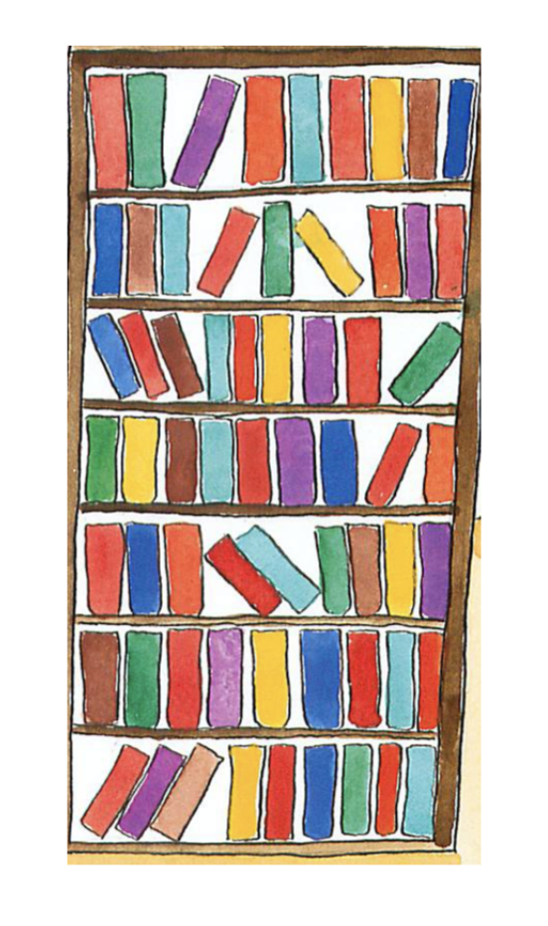
Examples

- There are nine books on each shelf. ( ✓ )
nine
b. There are eight books on each shelf. ( ❌)

- There are nine books in each group. ( )

- There are 9 equal groups.
( )

- There are 7 groups of nine. ( )

- It can be written as 7 x 9.
( )
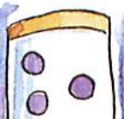
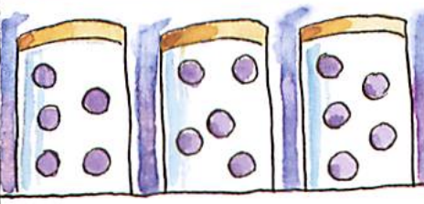

e. There are four equal groups. ( )

f. There are 5 groups of three. ( )

