Fractions in Disguise

PRE-READING TASKS
Prepare a mini presentation to share with us your personality and interest.
1) Describe your personality using fractions. Use the following circle to help you.
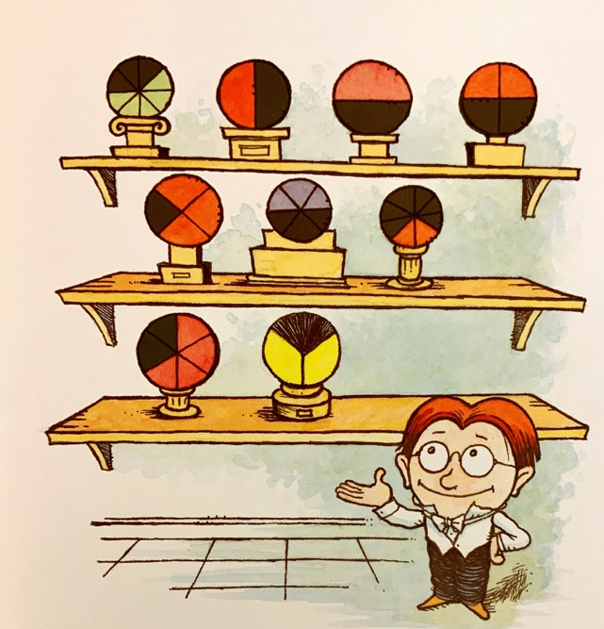

Mr. Factor’s personality:
1/4 genius, 1/4 stubborn, 1/3 determined, and 1/6 crazy
Adjective | Fraction

2) Are you a collector? What do you collect? How long have you been collection them? Where do you put them? Try to use fractions when you answer some of these questions.

WHILE-READING TASKS
1) Design your Reducer. List out the components using fractions.
Mr. Factor’s Reducer:  This Reducer is 1/2 ray gun and 1/2 calculator, made from a whole lot of paper clips, a whisk, some discarded computer parts, and sheer ingenuity. | Your Reducer:  ______________________________________  ______________________________________  ______________________________________  ______________________________________

2) Write your own problems about equivalent fractions. Challenge your neighbour. Then check your neighbour’s answers.

EXTENSION
1) Design your own Expander. List out the components using fractions and explain the function of your Expander.
Your Expander:

Components:
_________________________________________________________________________
_________________________________________________________________________
_________________________________________________________________________
Function:
_________________________________________________________________________
_________________________________________________________________________

2) Re-write the story (or part of the story) with your Expander.

TIPS
Culture is another significant element in a storytelling piece. While students re-write the story, instead of using the names from the original text such as Baron von Mathematik, Madame de Geometrique, encourage students to play around the names of the characters with reference to their own culture.

One cannot separate the culture from the text. (Bharucha, 1993:70)

