Special thanks to the participating teachers of the Book Club meeting for sharing their ideas with us. 😊

Fractions in Disguise by Edward Einhorn

PRE-READING TASKS
💡 Ask students to prepare a mini presentation to share their personality and interest.
Q1: Describe your personality using fractions. Use the following diagram to help you.

Adjective | Fraction

Different objectives could be achieved:
- comparing fractions
- expanding fractions by folding the diagram
- adding fractions to make a whole
- reading fractions correctly 📚MATH+ENGLISH
- adjectives to describe personality traits 📚ENGLISH
- comparative and superlative of adjectives 📚ENGLISH

Q2: Are you a collector? What do you collect? How long have you been collection them? Where do you put them? Try to use fractions when you answer some of these questions.
(Purpose: allow students to relate fractions to their daily life)

💡 Pose question while reading the book title:
Q: What does ‘disguise’ mean? 📚ENGLISH

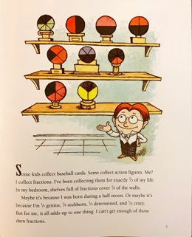 | TEACHING IDEAS (P.3)  💡 Turn the “fraction” display into realia for demonstration of fractions in class.  💡 Ask students to use other representations (e.g. number lines, Cuisenaire-rods, drawings) to present and compare fractions.  💡 Pose questions while reading this page:  Example 1  Mr. Factor has a wide collection of fractions. What are the fractions that he actually has? Represent the fractions using drawings or other manipulatives according to the story/teacher’s instruction. Are there any equivalent fractions?  Example 2  First shelf: (a) (b) (c) (d)  Second shelf: (e) (f) (g)  Third shelf: (h) (i)  Q1: Why are the fractions (h) and (i) put on the third shelf? Are they the same/different? (Hints: reduce the fraction)  Q2: Are the fractions on the second shelf the same/different?  Q3: If all the fractions are the same/different on each shelf, is fraction (a) put in the right place?  Q4: Which fractions are the same/different? How are they the same/different?  💡 Students work in pairs to finish Mr. Factor’s profile (e.g. his interests, characteristics). 📚ENGLISH  💡 Challenge the students if ‘it all adds up to one thing’ through colouring some boxes (without introducing addition of fractions). 📚MATH+ENGLISH  💡 Use other representations such as number lines to illustrate the idea of ‘2/3 of my life’ (without introducing multiplication of fractions).

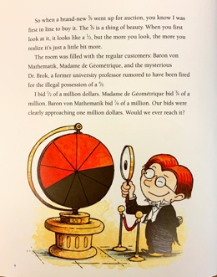 | TEACHING IDEAS (P.4)  💡 Model an auction and play with students.  💡 Pose questions while reading this page:  Q1: Compare the three fractions using different representations.  Q2: What is 1/2 of a million dollars?  Q3: What does ‘approaching one million dollars’ mean?  Q4: Can the three characters ever reach one million dollars?
TEAHCING IDEA (P.6)
💡 Pose question while reading this page:
Q: What does ‘there’s a foul play afoot’ mean? 📚ENGLISH

TEACHING IDEA (P.8)
💡 Ask students to write number sentences while reading this page.

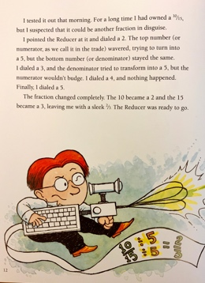 | TEACHING IDEAS (P.12)  💡 Ask students to translate the text to number sentences.  💡 Design a worksheet including the following questions.  Q1: Design your Reducer. List out the components using fractions. 📚MATH+ENGLISH+ART  Q2: Write your own problems about equivalent fractions. Exchange your problems with a peer and ask him/her to solve the problems. Then check your peer’s answers using your own reducer.
EXTENSION
💡 Design a worksheet including the following questions.
Q1: Design your own Expander. List out the components using fractions and explain the function of your Expander.
Q2: Re-write the story (or part of the story) with your Expander. 📚MATH+ENGLISH

TIPS
Culture is another significant element in a storytelling piece. While students re-write the story, instead of using the names from the original text such as Baron von Mathematik, Madame de Geometrique, encourage students to play around the names of the characters with reference to their own culture.

One cannot separate the culture from the text. (Bharucha, 1993:70)

